- INTRODUCTION

1. INTRODUCTION

1.1 PROBLEM STATEMENT

In today’s rapidly growing logistics industry, companies are under constant pressure to deliver goods faster, cheaper, and more efficiently. However, most delivery planning systems mainly focus on minimizing distance or cost, while ignoring another critical factor carbon emissions.With increasing environmental concerns and strict sustainability regulations, transportation has become one of the major contributors to carbon emissions. Many companies still rely on traditional route planning methods that do not consider fuel consumption patterns, traffic conditions, vehicle load, or environmental impact. As a result, businesses unknowingly increase their carbon footprint while also facing higher operational costs. There is a clear need for an intelligent system that not only optimizes delivery routes but also actively reduces carbon emissions. Companies require a smart and reliable platform that balances cost, efficiency, and environmental responsibility all in one solution.

1.2 PROPOSED SYSTEM

To address these challenges, EcoRoute AI is designed as a smart, AI-powered logistics optimization platform that balances operational efficiency with environmental responsibility. The system uses advanced optimization techniques to generate routes that minimize both transportation costs and carbon emissions simultaneously. By integrating a machine learning–based emission prediction model, EcoRoute AI can accurately estimate fuel consumption and environmental impact under different conditions. The platform also provides an interactive dashboard where users can visualize optimized routes, monitor performance metrics, and analyze emission trends over time. With its data-driven approach and intelligent decision-making capabilities, EcoRoute AI helps organizations reduce fuel usage, lower carbon emissions, and make more sustainable logistics choices without compromising delivery performance.

1.3 FEATURES OF THE PROPOSED SYSTEM

The proposed EcoRoute AI system will offer the following key features:

- User Registration and Authentication – Users can securely register and log in to the platform using encrypted credentials, ensuring that logistics data and operational details remain protected.
- Role-Based Access Control – The system provides different access levels for administrators and operational users, allowing secure management of routes, vehicle data, and performance reports.
- Route and Fleet Data Management – Users can input, update, and manage delivery locations, vehicle details, load information, and other logistics parameters required for route optimization.
- Multi-Objective Route Optimization– The system intelligently generates optimized delivery routes by considering multiple factors such as distance, cost, fuel consumption, and carbon emissions.
- AI-Based Emission Prediction – An integrated machine learning model estimates fuel usage and carbon emissions for different routes, helping organizations make environmentally responsible decisions.
- Performance Monitoring and Analytics – Users can track route efficiency, fuel consumption trends, and emission statistics through interactive dashboards and visual reports.
- Admin Dashboard – Administrators can oversee system performance, manage users, monitor logistics data, and ensure the reliability and integrity of the platform.
- RESTful API Integration – The system uses Flask as the backend to provide RESTful API communication with the React frontend, while PostgreSQL securely stores route, vehicle, and performance data to ensure smooth and reliable integration.
- Reporting and Summaries – The system allows users to generate detailed summaries of route performance, emission comparisons, and cost analysis to support data-driven decision-making.

2. FUNCTIONAL REQUIREMENTS

2. FUNCTIONAL REQUIREMENTS

2.1 User Authentication

Login: Users (operational users and admins) can log in using their username and password.

Registration: New users can create an account securely.

Password Recovery: Users can reset forgotten passwords via email verification.
2.2 Route and Fleet Data Management
- Input Route Details: Users can enter and update delivery locations, distance parameters, and scheduling information.
- Manage Vehicle Data: Users can add, edit, or remove vehicle details such as fuel type, capacity, and load information.
- Validation: The system validates all inputs to ensure accurate optimization and emission prediction results.
2.3 Route Optimization and Reports
- Automatic Route Optimization: The system generates optimized routes based on cost, distance, fuel consumption, and carbon emissions.
- Emission and Performance Reports: Users can view detailed breakdowns of fuel usage, emission levels, and route efficiency.
- Download/Export Reports: Users can export optimization summaries and emission reports for analysis and documentation purposes.
- AI-Based Insights: The AI module provides emission predictions, explains optimization results, and suggests environmentally efficient route alternatives.
2.4 Admin Controls and Data Management
- User Management: Admins can view and manage all registered users and their operational data while maintaining privacy and security standards.

- System Monitoring: Admins can monitor system performance, track optimization processes, and ensure data integrity.
- Data Security: Admins enforce secure access control and maintain backups of sensitive logistics and operational data.
2.5 User Profile Management
- View and Edit Profile: Users can update their personal and organizational details.
- Route History: Users can access a history of previous route optimizations, emission analyses, and performance reports.

3. NON-FUNCTIONAL REQUIREMENTS

3. NON-FUNCTIONAL REQUIREMENTS

PERFORMANCE
The platform must efficiently handle multiple users submitting route data and requesting optimization simultaneously, ensuring fast route generation and emission analysis. Optimized routes and dashboard reports should load within 2–3 seconds, even during peak usage. The system should support up to 500 concurrent users without performance degradation or noticeable delays.

SCALABILITY
The system should be designed to scale as logistics operations grow, supporting increasing numbers of vehicles, routes, and users. It must maintain high availability with minimal downtime during updates and be capable of recovering quickly from failures to prevent disruption of route optimization services.

USABILITY
The interface should be intuitive and easy to navigate, allowing users to input route details, manage fleet data, and view optimization results without confusion. Clear instructions, visualizations, and feedback messages should guide users through the process, ensuring a smooth and efficient experience.

SECURITY
Sensitive data, including user credentials, route information, and operational records, must be encrypted during storage and transmission. The system should implement secure authentication, role-based access control, and strict data isolation to ensure users can only access their authorized information.

MAINTAINABILITY
The platform should follow modular and well-documented development practices using React, Flask, and PostgreSQL to simplify future updates and debugging. System logs should be maintained for optimization processes, user activity, and error tracking to support auditing and troubleshooting.

COMPATIBILITY
The application should be compatible with modern web browsers such as Chrome, Firefox, Safari, and Edge. It should support both desktop and tablet devices to allow flexible access for logistics managers and operational teams.

SUPPORTABLITY
The system’s architecture and codebase should be clearly documented to ensure easy maintenance and future enhancements. User guidance, help sections, and documentation should be available to assist users in understanding route optimization features and emission analysis tools effectively.

4. UML DIAGRAMS

4.1 USE CASES
EcoRoute AI Use Cases:
4.1.1 User Registration

ID:UC-01
Name: User Registration
Description:
Allows a new logistics user (fleet manager, planner, or admin) to create an account in EcoRoute AI by providing required details and selecting a role.
Pre-conditions:
- User is not already registered
- System is online
Post-conditions:
- User account is created successfully
- User can log in to EcoRoute AI
Main Flow:
- User opens the registration page
- User enters name, email, password, and role (Planner / Manager / Admin)
- System validates the entered data
- System securely stores user details in the database
- System confirms successful registration
Alternative Flow:
- Email already exists → error message displayed
- Missing or invalid fields → system requests valid input

4.1.2 User Login

ID:UC-02
Name: User Login
Description:
Allows registered users to log in using valid credentials.
Pre-conditions:
- User must be registered

- Account must be active
Post-conditions:
- User is authenticated
- User is redirected to the appropriate dashboard
Main Flow:
- User opens login page
- User enters email and password
- System verifies credentials
- System generates authentication token
- User is logged in successfully
Alternative Flow:
- Invalid credentials → error message
- Blocked account → access denied

4.1.3 Route Optimization Request

ID:UC-03
Name: Carbon-Optimized Route Planning
Description:
Allows users to generate optimized routes minimizing cost, distance, and carbon emissions.
Pre-conditions:
- User must be logged in
Post-conditions:
- Optimized route is generated
- Emission data is calculated and stored
Main Flow:
- User enters delivery locations and vehicle details
- System applies multi-objective VRP optimization
- Emission prediction model calculates CO₂ output
- Optimized routes are displayed

Alternative Flow:
- Invalid input data → system requests correction

4.1.4 Emission Analysis & Visualization

ID:UC-04
Name: Emission Analytics Dashboard
Description:
Provides visual insights into fuel usage, distance traveled, and carbon emissions.
Pre-conditions:
- User must be logged in
- Route data must exist
Post-conditions:
- Emission graphs and metrics are displayed
Main Flow:
- System retrieves historical route data
- Emissions are aggregated
- Interactive charts are generated
- Dashboard displays results
Alternative Flow:
- No historical data → default message shown

4.1.5 Scenario Comparison

ID:UC-05
Name: Route Scenario Comparison
Description:
Allows users to compare multiple routing strategies based on emissions, cost, and time.
Pre-conditions:
- User must be logged in
Post-conditions:
- Best route scenario is highlighted
Main Flow:
- User selects multiple routing strategies
- System compares metrics

- Best scenario is recommended

4.1.6 Fleet Management

ID:UC-06
Name: Fleet & Vehicle Management
Description:
Allows users to add, update, and manage fleet vehicles.
Pre-conditions:
- User must be logged in
Post-conditions:
- Fleet data updated successfully
Main Flow:
- User adds vehicle details
- System validates data
- Vehicle stored in database

4.1.7 System Monitoring (Admin)

ID:UC-07
Name: Platform Monitoring
Description:
Admin monitors system performance and optimization accuracy.
Pre-conditions:
- Admin must be logged in
Post-conditions:
- System health reports available

4.1.8 User Management (Admin)

ID:UC-08
Name: Manage Users
Description:
Admin manages user accounts and roles.
Pre-conditions:
- Admin logged in

Post-conditions:
- User status updated

4.2 USECASE DIAGRAM

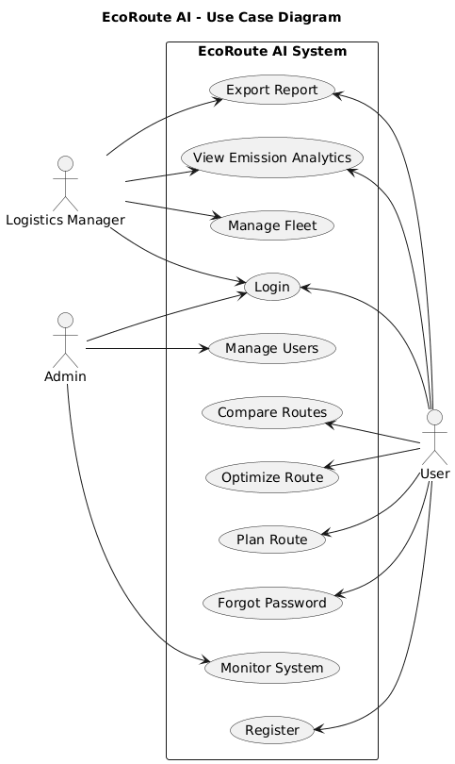

Fig . 4.2.1 Use Case Diagram

4.3 ACTIVITY DIAGRAM

4.3.1 USER/Driver

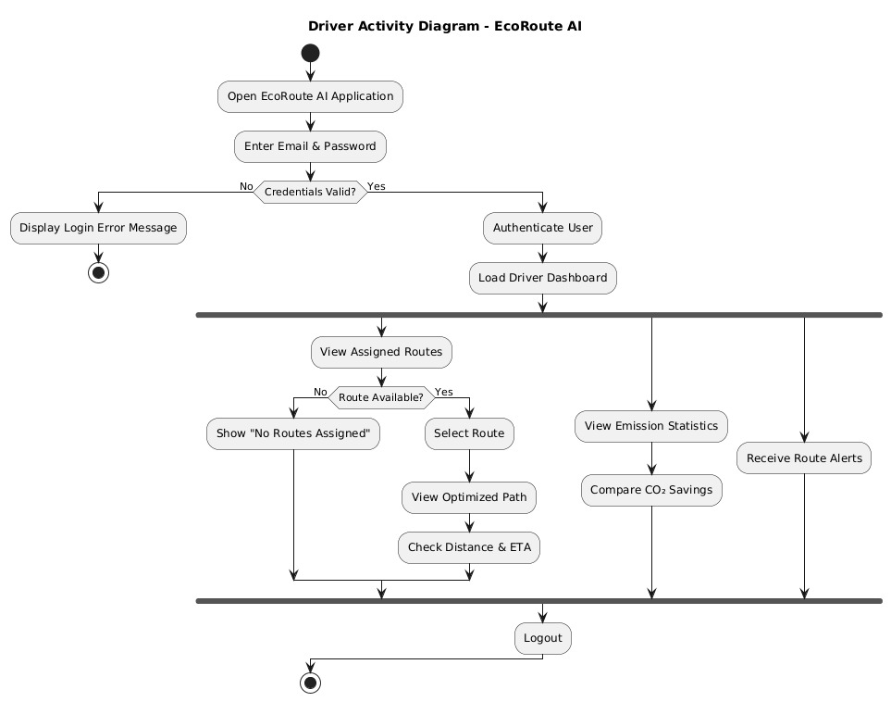

Fig . 4.2 Activity Diagram - User

4.3.2 LOGISTICS MANAGER

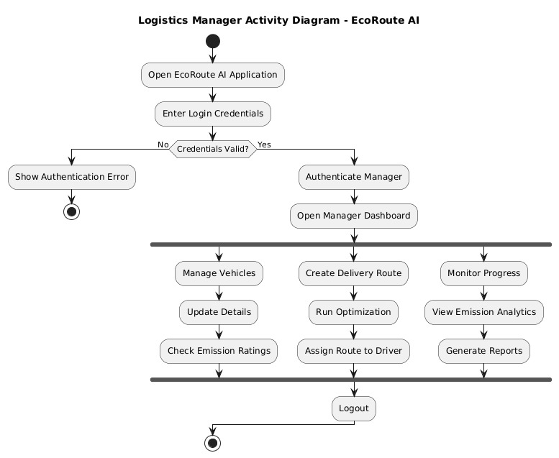

Fig . 4.3 Activity Diagram – Logistic Manager

4.3.3 ADMIN

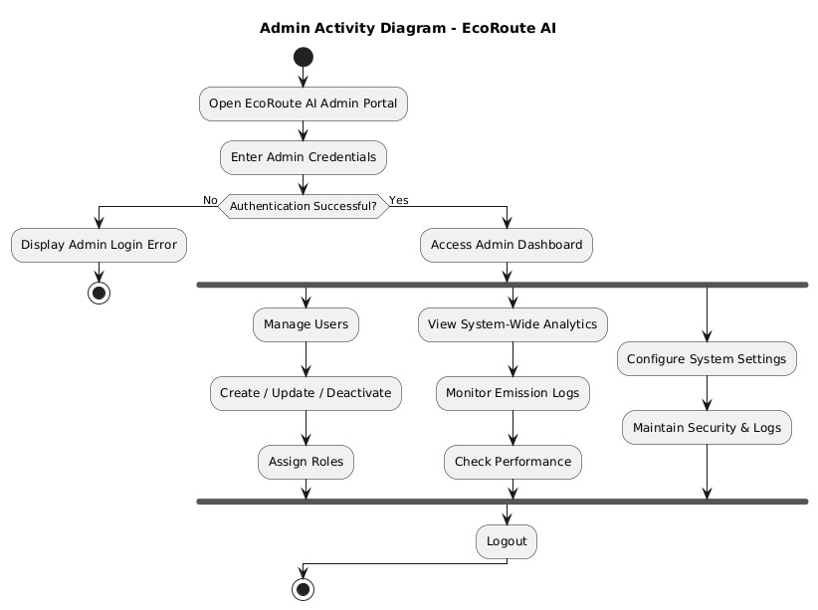

Fig . 4.4 Activity Diagram – Admin

4.4 CLASS DIAGRAM

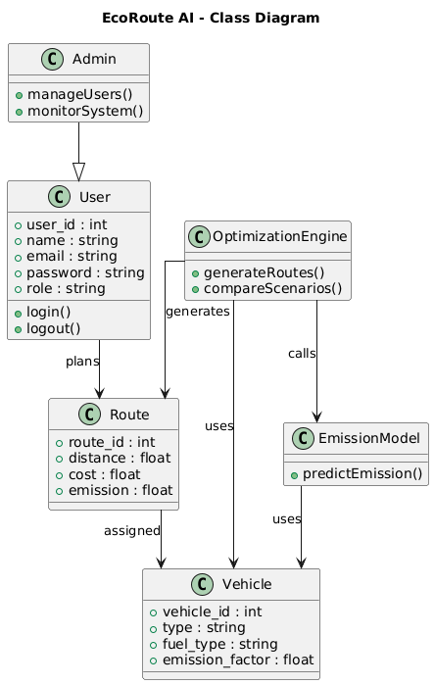

Fig . 4.5 Class Diagram

5. TEST CASES

5. TEST CASES

5.1 LOGIN
SR_NO | TEST CASE | FEATURE | DESCRIPTION | STEPS TO EXECUTE | EXPECTED RESULTS
1 | TC-01 | User Interface | Check the appearance of the login page | 1. Load the login page of EcoRoute AI | UI elements should be properly aligned, login fields and navigation links should function correctly
2 | TC-02 | Login Form | Verify login with valid credentials | 1. Open login page 2. Enter valid email and password 3. Click “Login” | User is redirected to the dashboard
3 | TC-03 | Login Form | Verify login with invalid credentials | 1. Open login page 2. Enter invalid email/password 3. Click “Login” | User remains on login page with error message “Invalid email or password”
4 | TC-04 | Password Recovery | Verify “Forgot Password” functionality | 1. Open login page 2. Click “Forgot Password” 3. Enter registered email | Password reset link or OTP is sent to registered email

Table 5.1 Test Case For Login

5.2 REGISTRATION
SR_NO | TEST CASE | FEATURE | DESCRIPTION | STEPS TO EXECUTE | EXPECTED RESULTS
1 | TC-01 | User Interface | Check the appearance of the registration page | 1. Load registration page of EcoRoute AI | UI elements properly aligned, input labels clear
2 | TC-02 | Registration Form | Verify behavior with empty fields | 1. Open registration page 2. Click “Register” | Error messages displayed for required fields
3 | TC-03 | Registration Form | Validate form with invalid data | 1. Enter invalid email or weak password 2. Click “Register” | Error messages shown, registration blocked
4 | TC-04 | Registration Form | Check successful registration with valid data | 1. Fill valid details 2. Click “Register” | Registration successful, user redirected to login page
5 | TC-05 | Login Functionality | Verify login after registration | 1. Use newly registered credentials 2. Click “Login” | Login successful, user lands on dashboard

Table 5.2 Test Case For Registration

5.3 VEHICLE AND ROUTE MANAGEMENT (USER)
SR_NO | TEST CASE | FEATURE | DESCRIPTION | STEPS TO EXECUTE | EXPECTED RESULTS
1 | TC-01 | Vehicle Entry | Verify user can add vehicle details | 1. Login 2. Navigate to Vehicles page 3. Enter vehicle details 4. Click “Save” | Vehicle details saved successfully
2 | TC-02 | Route Entry | Verify user can input route details | 1. Navigate to Route Planner 2. Enter origin, destination, load details 3. Click “Optimize” | Route is processed and optimization result displayed
3 | TC-03 | Input Validation | Verify invalid input handling | 1. Enter negative or non-numeric values for distance/load 2. Click “Save/Optimize” | System displays validation error and prevents submission
4 | TC-04 | Optimization Result | Verify route optimization output | 1. Enter valid route data 2. Click “Optimize” | Optimized route, cost estimate, and emission prediction displayed correctly

Table 5.3 Test Case for Vehicle and Route Management

6. INPUT DESIGN AND
OUTPUT DESIGN

6. INPUT DESIGN AND OUTPUT DESIGN

6.1 INPUT DESIGN
The input design of EcoRoute AI focuses on simplicity, accuracy, and user-friendliness to ensure smooth data entry for both operational users and administrators. The system is designed to minimize errors, validate critical inputs, and improve overall usability during route planning and emission analysis.

User Input Design:
Login and Registration Forms:
- Users can register and log in using their email and password.
- Form fields are clearly labeled and easy to understand.
- Password fields include validation rules (minimum length and character requirements) to enhance account security.
Route and Fleet Data Entry:
- Users can enter delivery locations, distance parameters, scheduling details, and route constraints.
- Users can add vehicle information such as fuel type, load capacity, and efficiency metrics.
- Validation ensures numeric fields such as distance, fuel consumption, and load weight are correctly formatted, and mandatory fields are not left empty.
Navigation and Interaction:
- Users can easily navigate between route entry, fleet management, optimization results, and performance history pages.
- Search and filter options allow quick access to previous route optimization records and emission reports.

Admin Input Design:
User Management:
- Admins can track system logs, optimization processes, and error reports.

- Validation mechanisms ensure that critical admin actions (such as deleting users or resetting system data) require confirmation before execution.
System Monitoring:
- Admins can track system logs, optimization processes, and error reports.
- Validation mechanisms ensure that critical admin actions (such as deleting users or resetting system data) require confirmation before execution.

Data Validation:
- Real-time validation is applied across all forms, including registration, route entry, and vehicle data input.
- Email format, password strength, and numerical values such as distance and fuel usage are validated at both frontend (React) and backend (Flask) levels.
- Mandatory fields are clearly marked to prevent incomplete submissions.
- Clear and informative error messages guide users to correct mistakes quickly and efficiently.

6.2 OUTPUT DESIGN
6.2.1. Introduction to Output Design
The output design of EcoRoute AI is focused on delivering clear, accurate, and actionable insights to both operational users and administrators. The system enhances decision-making through interactive dashboards, route optimization summaries, emission reports, and structured analytics. All outputs are designed to be visually understandable, data-driven, and easy to interpret.
User Output Design:
User Dashboard:
- Displays a summary of logistics activities, including recent route optimizations, total distance covered, estimated fuel consumption, and total carbon emissions.
- Shows statistics such as the number of routes optimized, emission trends, cost comparisons, and performance summaries.

Route Optimization Summary Page:
- Presents a detailed breakdown of each optimized route, including delivery points, total distance, fuel usage, estimated emissions, and cost analysis.
- Provides export options for downloading reports in formats such as PDF or CSV for documentation and analysis purposes.

History Section:
- Displays past route optimization records in a structured and chronological format.
- Includes details such as optimization date, route parameters, total emissions, fuel consumption, and efficiency metrics for easy reference and comparison.

Admin Output Design:
Admin Dashboard:
- Provides an overview of system activity including:
  - Total registered users
  - Total number of route optimizations performed
  - Overall emission statistics and system alerts

User Management Panel:
  - Displays a list of users with details such as name, email, role, and activity status.
  - Allows administrators to view user profiles and their route optimization history.

System Monitoring Panel:
  - Displays logs of system activity, optimization processes, errors, and significant user actions.
  - Provides tools to monitor algorithm performance and ensure secure and accurate data management.

Key Output Features:
- Real-Time Feedback: Users receive instant notifications after actions such as saving route data or generating optimized routes.
- Confirmation Messages: Displayed for actions like profile updates, data submissions, or system changes.
- Structured and Visual Reports: Optimization results, emission analysis, and performance metrics are presented using tables, charts, and clear headings to ensure readability across desktop and tablet devices.
- Exportable Outputs: Users can download route summaries and emission reports for operational planning, documentation, and sustainability reporting.

7. SYSTEM IMPLEMENTATION

7. System Implementation

7.1 Introduction
The EcoRoute AI system is a full-stack web application developed to support carbon-aware logistics optimization and intelligent route planning. It is designed to help organizations generate cost-efficient routes while minimizing environmental impact, and to provide administrators with tools for managing users and monitoring system performance. The frontend is built using React.js, offering a dynamic, responsive, and interactive user interface that allows users to input route details, manage fleet data, and visualize optimization results through dashboards and charts. The backend is implemented using Flask, which handles API requests, route optimization processing, emission prediction logic, and secure authentication mechanisms. PostgreSQL is used as the database to store user profiles, vehicle information, route parameters, optimization results, and performance logs in a structured and reliable manner. Secure authentication and role-based access control mechanisms ensure protected access to system resources. Additionally, the platform integrates a machine learning–based emission prediction model that enhances decision-making by estimating fuel consumption and carbon output for different routes. This overall architecture creates a scalable, efficient, and intelligent logistics platform that balances operational performance with environmental sustainability.

7.2 Project Structure
The EcoRoute AI project follows a clean and modular architecture with a clear separation between frontend and backend components, ensuring scalability, maintainability, and ease of development. The system is organized into independent folders for the backend and frontend, allowing smooth development, testing, and deployment processes.
EcoRoute-AI/
│
├── backend/ # Backend API (Python + FastAPI)
│ ├── app/ # Main application logic
│ │ ├── routers/ # API routes (Auth, Optimization, Vehicles, Analytics)

│ │ ├── models.py # SQLAlchemy models (User, Vehicle, Route, OptimizationRecord)
│ │ ├── schemas/ # Pydantic schemas for validation and serialization
│ │ ├── services/ # Business logic (Route optimization, Emission prediction)
│ │ ├── core/ # Security (JWT), configuration, dependencies
│ │ ├── database.py # Database connection and session management
│ │ └── main.py # FastAPI entry point and middleware setup
│ ├── requirements.txt # Python dependencies
│ ├── .env # Backend environment variables (DB_URL, SECRET_KEY)
│ └── run.py # Development server startup script
│
├── frontend/ # Frontend (React.js)
│ ├── public/ # Static assets (index.html, favicon)
│ ├── src/
│ │ ├── components/ # Reusable UI components
│ │ ├── pages/ # Pages (Dashboard, Map, Reports, Profile)
│ │ ├── services/ # API integration using Axios (api.js)
│ │ ├── styles/ # Global and component-level CSS
│ │ ├── utils/ # Utility and helper functions
│ │ ├── App.js # Main React component and route configuration
│ │ └── index.js # React DOM entry point
│ ├── package.json # Frontend dependencies and scripts
│ └── .env # Frontend environment variables (API_URL, Maps Keys)
│
├── ml/ # Machine Learning models (Emission prediction, Optimization)
├── database/ # Database setup and migration scripts
├── tests/ # Unit and integration tests
├── docs/ # Project documentation and API specifications
└── README.md # Project overview and setup guide

Each backend module is responsible for specific operations such as request handling, route optimization processing, emission prediction, data validation, and response formatting. The frontend is developed as a single-page application (SPA) using reusable React components
to provide a dynamic, responsive, and visually interactive experience for users managing logistics and sustainability analytics.

7.3. Database Design and Models
The EcoRoute AI system utilizes PostgreSQL, a robust relational database management system, to ensure structured, consistent, and reliable data storage. SQLAlchemy is used as the Object-Relational Mapping (ORM) tool to define database models and manage relationships efficiently. The database is designed to maintain data integrity, scalability, and efficient handling of user information, vehicle details, route parameters, and optimization results.
Primary Data Models:
- User Fields: id, name, email, passwordHash, role, createdAt
- Vehicle Fields: id, userId, vehicleType, fuelType, capacity, efficiency, createdAt
- Route Fields: id, userId, origin, destination, distance, loadWeight, createdAt
- Optimization Record Fields: id, userId, routeId, totalDistance, fuelConsumption, carbonEmission, totalCost, createdAt
Relationships:
- One-to-Many: A user can register multiple vehicles, create multiple routes, and generate multiple optimization records.
- Foreign Key References:
  - Vehicle.userId references User.id
  - Route.userId references User.id
  - OptimizationRecord.userId references User.id
  - OptimizationRecord.routeId references Route.id

Each model is structured to ensure smooth integration across system modules. The User model manages authentication and role-based access control. The Vehicle and Route models capture logistics and operational data required for optimization. The OptimizationRecord

model consolidates route parameters, emission predictions, and cost calculations to store the final optimized results. This relational design ensures accurate data tracking, performance monitoring, and efficient retrieval of historical analytics.

7.3.1 Table name: User Registration
Field Name | Data Type | Constraints | Description
user_id | SERIAL | PRIMARY KEY | Unique identifier for each user
full_name | VARCHAR(100) | NOT NULL | Full name of the user
email | VARCHAR(100) | NOT NULL, UNIQUE | User’s email used for login
organization | VARCHAR(150) | NULL | Organization or company name
password | VARCHAR(255) | NOT NULL | Hashed user password
role | VARCHAR(20) | DEFAULT 'user' | Role of the user (admin/user)
created_at | TIMESTAMP | DEFAULT CURRENT_TIMESTAMP | Date and time of registration

Table 7.1 User registration table database design

7.3.2 Table name: Vehicles
Field Name | Data Type | Constraints | Description
vehicle_id | SERIAL | PRIMARY KEY | Unique identifier for each vehicle
user_id | INTEGER | FOREIGN KEY REFERENCES Users(user_id) ON DELETE CASCADE | References the Users table
vehicle_type | VARCHAR(100) | NOT NULL | Type of vehicle (Truck, Van, etc.)
fuel_type | VARCHAR(50) | NOT NULL | Type of fuel (Diesel, Petrol, Electric, etc.)
fuel_efficiency | DECIMAL(5,2) | NOT NULL | Fuel efficiency (e.g., km/l)
load_capacity | DECIMAL(10,2) | NOT NULL | Maximum load capacity of vehicle
created_at | TIMESTAMP | DEFAULT CURRENT_TIMESTAMP | Record creation date

Table 7.2 Vehicles Table Database Design

7.3.3 Table name: Routes
Field Name | Data Type | Constraints | Description
route_id | SERIAL | PRIMARY KEY | Unique identifier for each route
user_id | INTEGER | FOREIGN KEY REFERENCES Users(user_id) ON DELETE CASCADE | References the Users table
vehicle_id | INTEGER | FOREIGN KEY REFERENCES Vehicles(vehicle_id) | Vehicle used for the route
origin | VARCHAR(150) | NOT NULL | Starting location
destination | VARCHAR(150) | NOT NULL | Ending location
distance | DECIMAL(10,2) | NOT NULL | Total distance of route (km)
load_weight | DECIMAL(10,2) | NOT NULL | Weight of goods transported
optimized | BOOLEAN | DEFAULT FALSE | Indicates whether route is optimized
created_at | TIMESTAMP | DEFAULT CURRENT_TIMESTAMP | Record creation date

Table 7.3 Routes Table Database Design

7.3.4 Table name: OptimizationResults
Field Name | Data Type | Constraints | Description
result_id | SERIAL | PRIMARY KEY | Unique identifier for optimization result
route_id | INTEGER | FOREIGN KEY REFERENCES Routes(route_id) ON DELETE CASCADE | References the Routes table
estimated_fuel | DECIMAL(10,2) | NOT NULL | Estimated fuel consumption
estimated_cost | DECIMAL(10,2) | NOT NULL | Estimated transportation cost
estimated_emission | DECIMAL(10,2) | NOT NULL | Predicted CO₂ emission
optimized_distance | DECIMAL(10,2) | NOT NULL | Optimized route distance
calculated_at | TIMESTAMP | DEFAULT CURRENT_TIMESTAMP | Timestamp of optimization

Table 7.4 OptimizationResults Table Database Design

7.3.5 Table name : EmissionRecords
Field Name | Data Type | Constraints | Description
emission_id | SERIAL | PRIMARY KEY | Unique identifier for emission record
route_id | INTEGER | FOREIGN KEY REFERENCES Routes(route_id) ON DELETE CASCADE | References the Routes table
vehicle_id | INTEGER | FOREIGN KEY REFERENCES Vehicles(vehicle_id) | References the Vehicles table
carbon_emission | DECIMAL(10,2) | NOT NULL | Calculated CO₂ emission value
recorded_at | TIMESTAMP | DEFAULT CURRENT_TIMESTAMP | Record creation time

Table 7.5 EmissionRecords Table Database Design

7.4 URL Routing and Views
The EcoRoute AI system uses FastAPI for handling URL routing, ensuring efficient and structured communication between the React frontend and the backend services. Each API endpoint corresponds to specific functionalities such as user authentication, vehicle management, route optimization, emission analysis, and administrative monitoring. The routing structure is modularized for better maintainability and scalability, with separate router modules for each major feature integrated into the main FastAPI application.

Routing Structure
Routes are organized into different modules to maintain clear separation of concerns:
- /api/users – Handles user registration, login, token generation (JWT), and profile management
- /api/vehicles – Manages vehicle-related operations such as adding, viewing, updating, and deleting vehicle details
- /api/routes – Handles route creation, modification, and retrieval of route parameters
- /api/optimization – Processes route optimization requests and generates cost and emission results
- /api/analytics – Provides emission statistics, performance reports, and historical optimization summaries
- /api/admin – Offers administrative controls including user management, system monitoring, and activity logs

Example Endpoints
Endpoint | HTTP Method | Description
/api/auth/register | POST | Register a new user
/api/auth/login | POST | Authenticate user and generate JWT token
/api/auth/profile/{id} | GET | Retrieve user profile details
/api/vehicles/add | POST | Add a new vehicle
/api/vehicles/{id} | PUT | Update existing vehicle details
/api/routes/create | POST | Create a new route with origin and destination
/api/optimization/run | POST | Generate optimized route with cost and emission analysis
/api/analytics/history | GET | Retrieve past optimization records
/api/admin/users | GET | Fetch all registered users (Admin only)

Views:

The frontend, developed using React.js, provides an intuitive and interactive user experience with the following key views:
- Home Page: Overview of EcoRoute AI features with login and registration access
- Login / Register Page: Secure authentication forms for user access
- Dashboard: Displays route optimization summaries, total distance covered, fuel consumption, and carbon emission statistics
- Vehicle Management Page: Add, update, or remove vehicle details
- Route Planning Page: Enter route details and generate optimized routes

HTTP Methods Used:

- GET: Retrieve user details, vehicle data, route history, and analytics reports
- POST: Submit new user registrations, vehicle entries, route details, and optimization requests
- PUT: Update existing vehicle information, route parameters, or user profiles
- DELETE: Remove vehicle records, route entries, or user accounts

7.5 Templates and Frontend Integration
- The frontend of the EcoRoute AI system is developed using React.js, a modern JavaScript library that enables dynamic rendering and efficient component

management. The application follows a component-based architecture to promote reusability, modularity, and clean code organization.
- A base layout component ensures a consistent structure across all pages and includes a header with navigation links such as Home, Dashboard, Vehicles, Route Planning, Analytics, and Profile, along with a footer containing project information and references. The user interface is fully responsive, ensuring compatibility across desktops, tablets, and mobile devices using CSS and modern styling frameworks.
- Static assets such as images, stylesheets, icons, and JavaScript utilities are organized within the public/ and src/assets/ directories to ensure optimized performance and structured project management.
Example frontend pages/components:
- HomePage.js – Introduces the EcoRoute AI platform with an overview of its features and sustainability goals.
- Register.js / Login.js – Manage user registration and login functionalities.
- Dashboard.js – Displays route optimization summaries, emission statistics, fuel consumption, and performance insights.
7.6 User Authentication and Authorization
User authentication in EcoRoute AI is implemented using secure password hashing mechanisms and JWT (JSON Web Tokens) for session management within the FastAPI backend. This ensures that user credentials are securely stored and that only authenticated users can access protected API endpoints. The system manages user registration, login, token generation, and logout processes, issuing secure tokens for authorized requests.
Custom User Roles are defined as follows:
- Admin: Can manage all users, monitor route optimization records, view system-wide analytics, and oversee platform performance.
- User: Can add and manage their own vehicles, create routes, generate optimized results, and view emission analytics related to their operations.

Role-Based Access Control (RBAC) is enforced using dependency-based authorization mechanisms in FastAPI to protect routes and ensure that only authorized users can perform specific actions. Administrative functionalities, such as accessing all user data or viewing

system logs, are restricted to admin users, while regular users can only access and manage their own operational data.

7.7 Forms and Validation
In EcoRoute AI, forms are used to collect user input for various logistics and optimization functionalities, including:
- User Registration: Captures full name, email, organization name, password, and confirm password for secure account creation.
- Login: Accepts email and password to authenticate users.
- Vehicle Entry: Allows users to add or update vehicle details such as vehicle type, fuel type, load capacity, and fuel efficiency.
- Route Entry: Enables users to enter route details including origin, destination, load weight, and scheduling information.
- Route Optimization: Collects route and vehicle parameters to generate optimized routes with cost and emission analysis.
- Profile Update: Allows users to update their personal or organizational details.

Validation Rules:
- Mandatory fields are required to prevent incomplete submissions.
- Email addresses must be in a valid format.
- Passwords are checked for strength and must meet minimum security criteria.
- Numeric fields such as distance, load weight, fuel efficiency, and cost are validated for correct format and logical values.

Error Handling and Feedback:
Custom error messages and real-time validation feedback guide users in correcting input mistakes. This improves usability and ensures accurate and reliable data entry across all route planning and vehicle management forms.

7.8 Business Logic and Core Functionality
The core functionality of EcoRoute AI focuses on intelligent route optimization, emission prediction, and performance analytics. The system implements the following business logic:

- Vehicle and Route Management:
Users can add, view, edit, or delete vehicle and route entries. Validation ensures that operational data such as fuel efficiency, load capacity, and route parameters are correctly entered.
- Tax Calculation:
TaxMate dynamically computes taxable income and tax liability based on user-provided income and deductions. Calculations are updated in real-time as data is added or modified.
- Multi-Objective Route Optimization:
The system processes user-provided route and vehicle data to generate optimized routes that balance distance, fuel consumption, operational cost, and carbon emissions. Optimization results are calculated dynamically and stored for future analysis.
- Emission Prediction:
A machine learning–based module estimates fuel usage and carbon emissions for selected routes, enabling environmentally responsible decision-making.
- Admin Controls:
Admins can monitor system-wide activity, manage user accounts, review optimization statistics, and ensure data integrity and secure operations.
- User Profile Management:
Users can manage their personal and organizational details. The dashboard provides a summary of routes optimized, total emissions, and overall performance indicators.
- AI Integration:

The platform integrates AI-driven emission prediction and intelligent optimization logic to provide data-backed recommendations for reducing fuel consumption and carbon footprint.

7.9 Testing and Debugging
Testing Process:
- Unit Testing: Individual backend modules such as User Management, Vehicle Management, Route Planning, Emission Prediction, and Optimization Engine are tested to ensure correct data processing and business logic implementation.

- API Testing: RESTful API endpoints for user registration, login, vehicle management, route optimization, and analytics are tested to verify proper request handling, response accuracy, and error management.
- Integration Testing: Interactions between the React frontend and FastAPI backend are tested to confirm smooth data exchange, correct API integration, and seamless workflow execution.
- User Acceptance Testing (UAT): The system is tested from the end-user perspective to ensure usability, accurate route optimization results, correct emission predictions, and reliable performance tracking.
Tools Used:
- Postman: For testing REST API endpoints and verifying request/response behavior.
- Browser Developer Tools: For inspecting frontend behavior, UI rendering, network requests, and debugging JavaScript issues.
Debugging:
- FastAPI Logging and print() Statements: Used to trace backend logic, monitor API responses, and resolve server-side issues.
- Browser DevTools: Used to detect JavaScript errors, monitor network activity, and debug styling or layout issues.
- Logs and Breakpoints: Implemented throughout the development process to aid in troubleshooting and ensure accurate operation of the system.

8. AI Integration

The AI Integration module in EcoRoute AI enhances decision-making by providing intelligent route optimization, emission prediction, and data-driven insights. This module simplifies complex logistics planning, improves fuel efficiency, and supports sustainable transportation strategies. The AI component uses machine learning models, optimization algorithms, and predictive analytics to deliver accurate and contextual recommendations.
1. AI Route Optimization Engine
The AI-powered optimization engine generates efficient routes by considering multiple operational parameters such as distance, fuel consumption, load capacity, and carbon emissions.
- Purpose: To minimize transportation cost and environmental impact while maintaining operational efficiency.
- Features:
  - Calculates shortest and most fuel-efficient routes.
  - Balances multiple objectives such as distance, cost, and emissions.
  - Adapts route recommendations based on vehicle type and load weight.
  - Stores optimization history for performance analysis.
- APIs / Technologies Used:
  - FastAPI backend for processing optimization requests.
  - Custom Optimization Algorithm (multi-objective logic).
  - PostgreSQL database for storing route and vehicle data.
  - Axios (React frontend) for secure API communication.
2. Emission Prediction Model
EcoRoute AI integrates a machine learning–based emission prediction system that estimates fuel consumption and CO₂ emissions for selected routes.
- Purpose: To help organizations reduce their carbon footprint and comply with sustainability goals.
- Features:
  - Predicts fuel usage based on distance, vehicle efficiency, and load.
  - Estimates carbon emissions for each optimized route.
  - Provides comparative analysis between alternative routes.
  - Supports environmentally responsible decision-making.

- APIs / Libraries Used:
  - Machine Learning model integrated within FastAPI.
  - Data preprocessing and prediction logic using Python-based ML libraries.
  - Internal Emission Calculation API for real-time estimation.
3. Intelligent Insights and Analytics
The AI module generates performance insights and visual analytics to improve operational planning.
- Purpose: To provide data-backed recommendations for improving logistics efficiency.
- Features:
  - Displays emission trends and fuel consumption analytics.
  - Highlights high-cost or high-emission routes.
  - Provides suggestions to improve route efficiency.
  - Tracks historical optimization performance.
- APIs / Technologies Used:
  - Chart libraries (e.g., Plotly or similar visualization tools) for dashboard analytics.
  - Custom Analytics API for structured data reporting.
4. Security and Data Handling
The AI module operates only within authenticated user sessions. All optimization and prediction requests are secured using JWT-based authentication in FastAPI. User-specific data such as vehicle details and route history are accessed securely through role-based authorization mechanisms. Sensitive operational data is protected to ensure privacy, data integrity, and secure system performance.

9. FUTURE ENHANCEMENTS

9. FUTURE ENHANCEMENTS

- Improved User Interface (UI/UX):
- Optimize the platform for mobile devices to ensure smooth navigation for route planning and vehicle management.
- Implement personalized dashboards displaying route summaries, emission statistics, fuel consumption trends, and performance insights tailored to each user.
- Advanced Route and Data Input Tools:
- Enhance route entry forms with auto-suggestions, dynamic distance calculations, and intelligent parameter recommendations.
- Enable document uploads for compliance records, fuel logs, or operational reports.
- Sustainability andManagement Features:
- Introduce fleet-level analytics for companies managing multiple vehicles.
- Provide scheduled optimization reports summarizing fuel savings and emission reductions.
- Intelligent Assistance and AI Enhancements:
- Enhance the AI engine to provide predictive route planning based on historical traffic and delivery patterns.
- Introduce AI-driven suggestions for fuel-efficient driving strategies.
- Implement anomaly detection to identify unusually high fuel consumption or emission spikes.
- Admin Panel Enhancements:
- Offer detailed analytics on system usage, route optimization frequency, and emission reduction trends.
- Enable bulk management of users, vehicles, and route records.
- Provide downloadable system-wide performance and sustainability reports.
- Use AI-based monitoring to detect abnormal operational patterns or data inconsistencies.

- Security Improvements:
- Implement two-factor authentication (2FA) for user and admin logins.
- Enhance data privacy through encrypted communication, secure session handling, and audit logging of sensitive operations.
- Performance Optimization:
- Improve system load times using caching, optimized API responses, and server-side computations where appropriate.
- Enhance route computation speed through algorithm refinement and server-side optimizations.
- Implement AI-based system monitoring to predict performance bottlenecks and optimize resource allocation.

10. CONCLUSION

10. CONCLUSION

The EcoRoute AI system provides an intelligent and efficient platform for sustainable route planning, vehicle management, and emission analysis. By combining a user-friendly React frontend with a robust FastAPI backend and PostgreSQL database, the platform ensures secure, accurate, and seamless handling of logistics data for both users and administrators. EcoRoute AI simplifies complex route optimization processes through structured workflows, real-time calculations, and interactive dashboards, enabling organizations to make cost-effective and environmentally responsible decisions.
In addition to its core optimization capabilities, EcoRoute AI integrates AI-driven emission prediction and intelligent analytics to deliver data-backed insights. The system supports multi-objective optimization, helping users balance operational cost, fuel efficiency, and carbon footprint. Future enhancements such as predictive traffic integration, fleet-level analytics, AI-based anomaly detection, and enhanced sustainability reporting will further strengthen the platform’s effectiveness and scalability. Strong authentication mechanisms, role-based access control, and secure API communication ensure data privacy and system integrity.
Overall, EcoRoute AI serves as a comprehensive and forward-thinking logistics optimization solution that empowers organizations to improve operational efficiency, reduce environmental impact, and adopt smarter, greener transportation strategies.

11.ANNEXURE

11.1 SCREENSHOTS

11.1 Home page

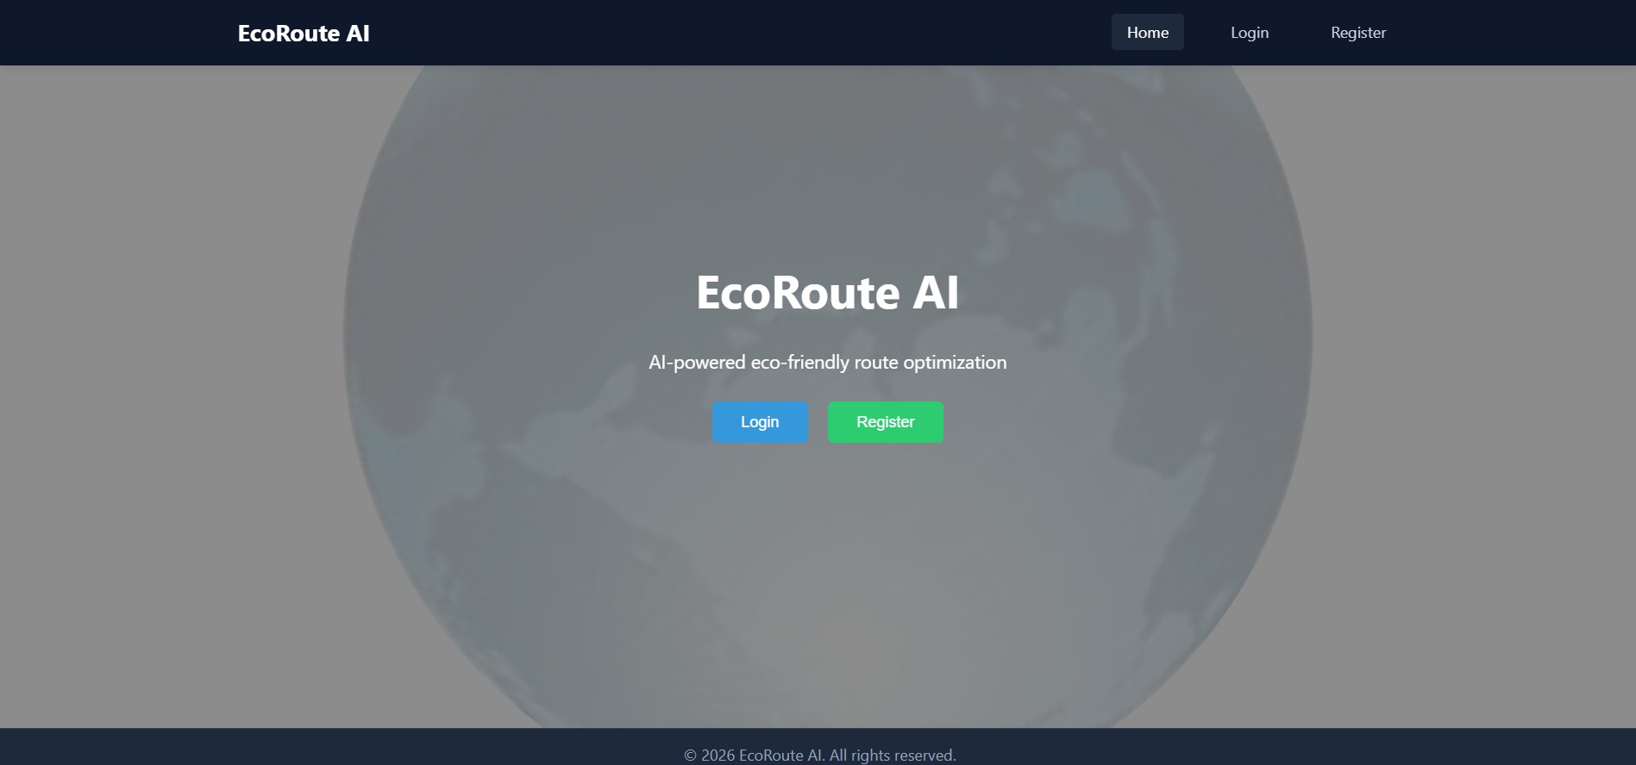

11.2 Register page

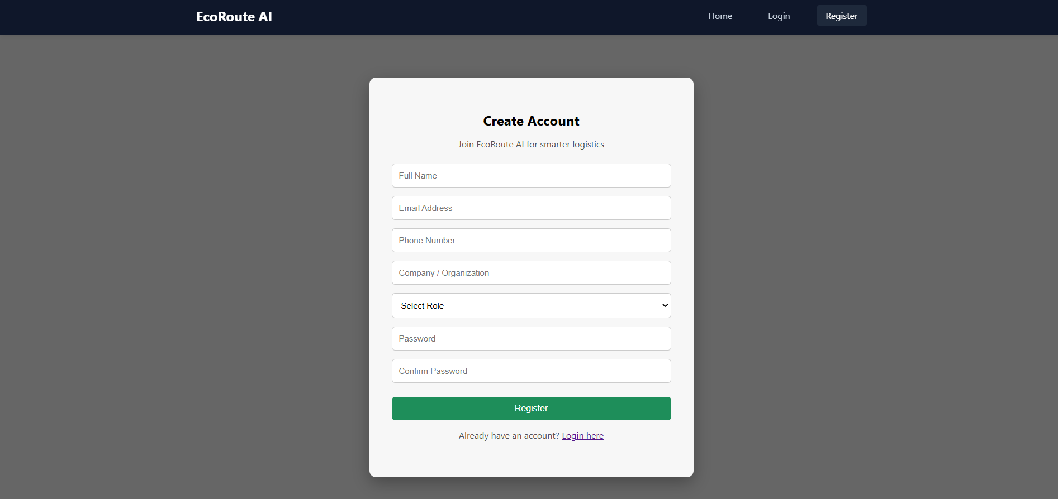

11.3 Login page

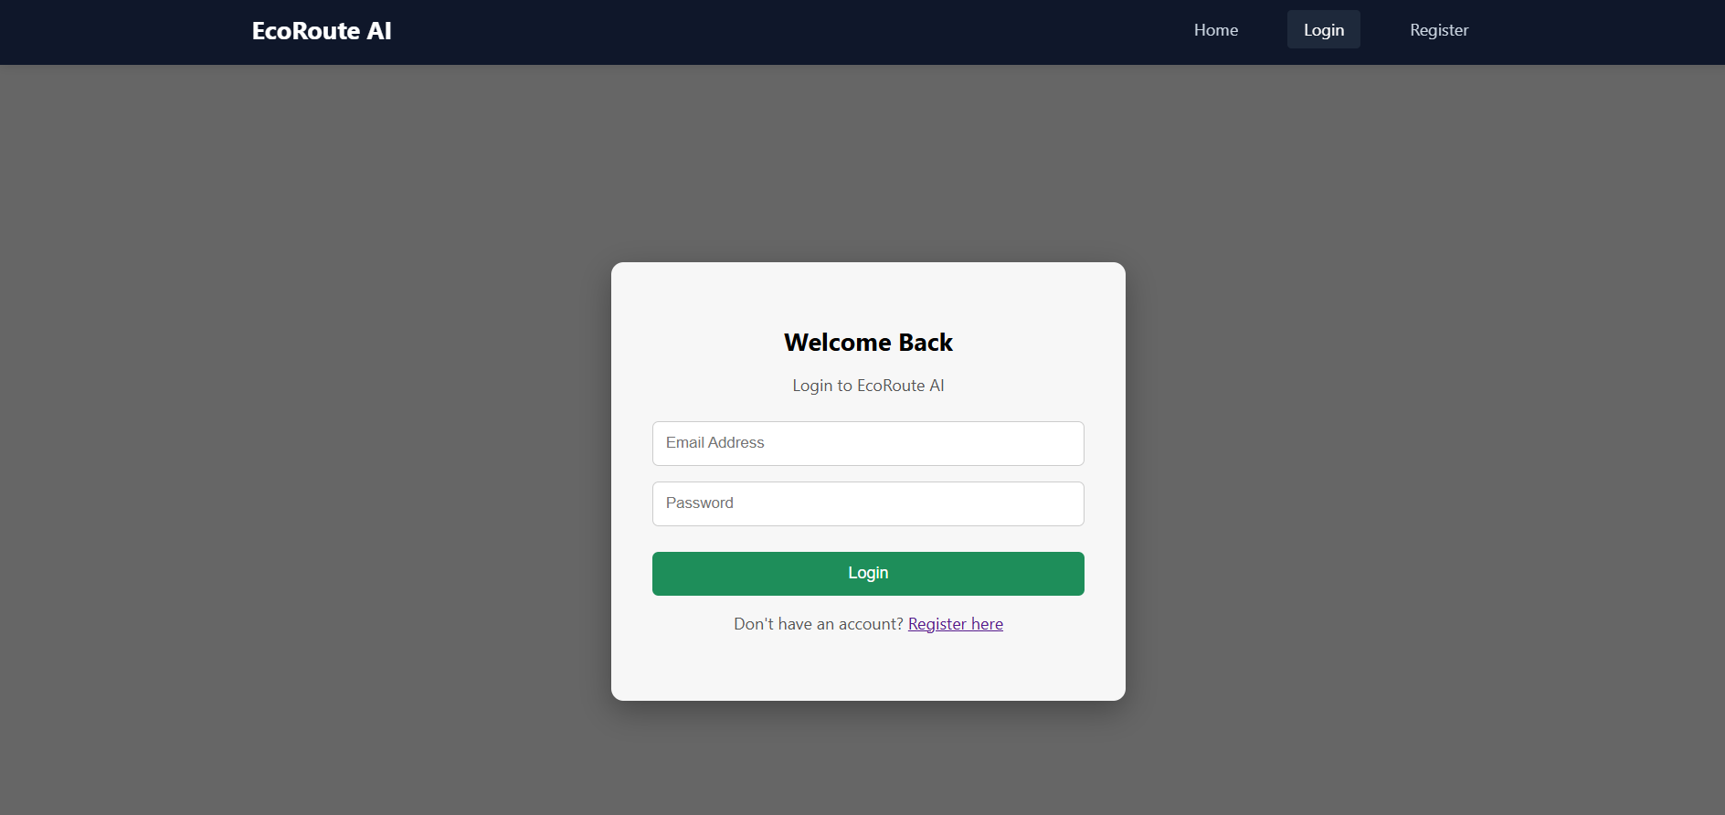

11.4 User page

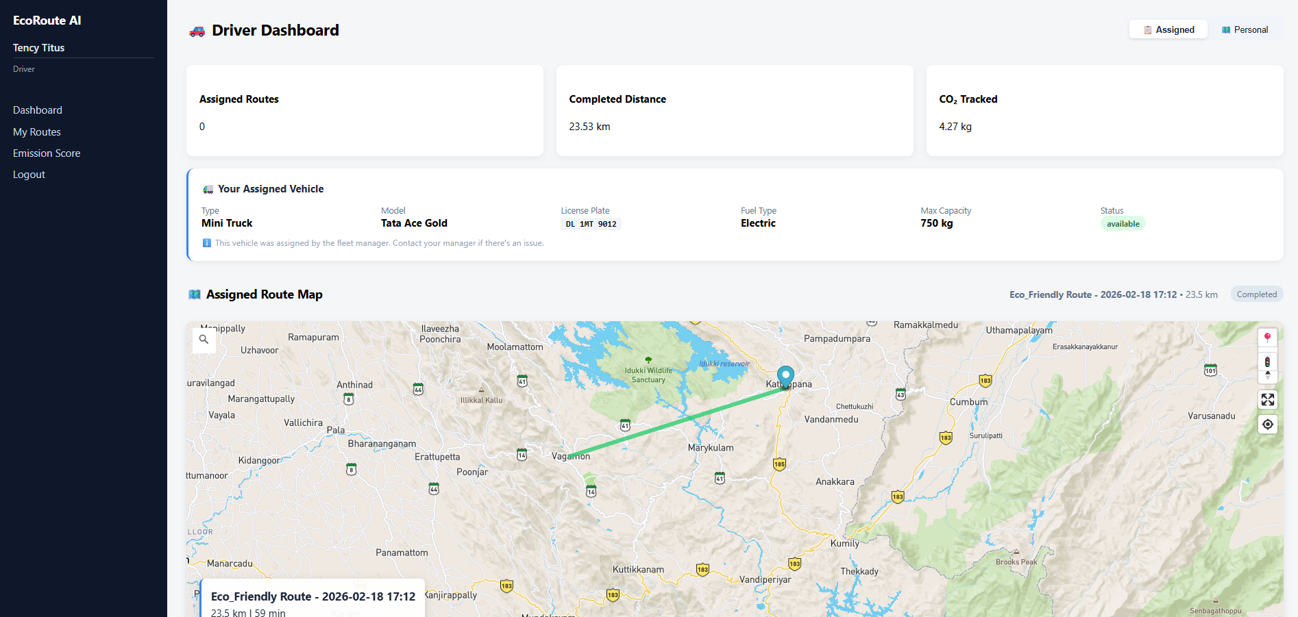

11.5 Route Planner page

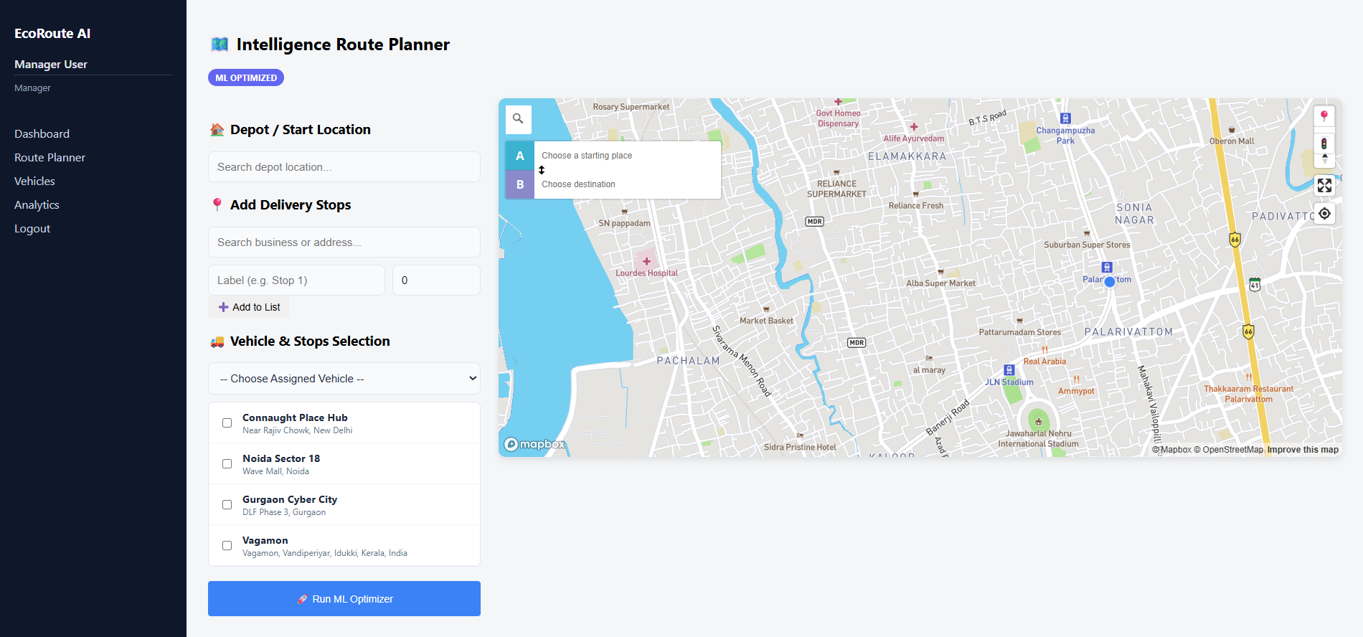

11.2 Ethical Clearance Form

MCA/BCA Student Dissertation / Capstone Ethical Clearance Form
Department: MCA Academic Year: 2025-2026

A. Student & Project Details
1. Student Name: Tency Titus
2. Admission Number: 2007
3. Programme of Study: MCA
4. Institution Email: tency.24pmc157@mariancollege.org
5. Contact Phone: 8590902737
6. Project/Dissertation Title: EcoRoute AI – Smart Route Optimization System
7. Project Modality: Capstone
8. Supervisor (Faculty Guide): Ms. Kochumol Abraham
9. DRAC/Departmental Research Advisory Member (if applicable):
10. Industry/External Mentor (if applicable):
11. Estimated Start Date: July 2026
12. Estimated Completion Date: September 2026

B. Project Overview
13. Purpose & Rationale (aim, research problem, expected contribution; attach pages if needed):
The project EcoRoute AI aims to develop an intelligent web-based platform for optimizing transportation routes and predicting carbon emissions. Many logistics operations rely on manual planning or basic navigation tools that do not consider fuel efficiency, load weight, and environmental impact simultaneously. EcoRoute AI addresses this issue by providing AI-driven route optimization, emission prediction, and performance analytics. The system contributes to sustainable transportation management by reducing fuel consumption, operational costs, and carbon footprint while improving decision-making efficiency.

14. Methodology / Technical Approach (check all that apply and describe below):
☐ Software/System Development
☐ AI/ML/DL Model Development
☐ Web Application
Brief description (design, datasets, tools, procedures, evaluation):
EcoRoute AI is developed using a React.js frontend, FastAPI (Python) backend, and PostgreSQL database. The system allows users to register, manage vehicles, input route parameters, and generate optimized routes. The backend implements JWT-based authentication and role-based access control for users and administrators. An AI-based optimization engine calculates optimal routes considering distance, cost, fuel efficiency, and emissions. The emission prediction module uses rule-based and machine learning logic to estimate carbon output. Evaluation includes optimization accuracy, emission estimation consistency, API performance, and user usability testing.
15. Software/Hardware & Infrastructure
- Primary languages/frameworks: React.js, FastAPI (Python), PostgreSQL
- External libraries/models: JWT (authentication), bcrypt (password hashing), Axios (API communication), Python ML libraries for emission prediction
- Compute/Cloud services: Render (deployment), PostgreSQL (database hosting)

C. Data, Participants, and Ethics

16. Does the study involve human participants (e.g., usability tests, surveys, interviews, behavioral logging)?
☐ No
If Yes, answer Q17–Q24. If No, skip to Q25.
17. Participant Recruitment (source, criteria, messages, incentives/honoraria):
18. Anticipated Impact/Risks to Participants (time burden, privacy, discomfort, potential risks):
19. Confidentiality & Anonymity (minimization, pseudonymization, access controls):
20. Informed Consent Procedure (consent form/script, withdrawal, parental consent, accessibility):

21. Sensitive Contexts (tick if applicable):
☐ Personal or sensitive topics ☐ Children or vulnerable adults
☐ Possible psychological/social/physical harm or distress
☐ Audio/video recording or screen capture ☐ Geo-location tracking or telemetry
If ticked, justify risk-mitigation measures and provide protocols:
22. Data Collection Details (Human Studies)
Instruments (surveys/interview guides/UX tasks):
Duration per participant: minutes
N (target):
Compensation (if any):
23. Debriefing & Support (post-study debrief, support contacts, complaint mechanism):
24. Privacy Notices (data use, storage, sharing, and participant rights):

If No Human Participants: Complete the Following

25. Datasets and Digital Sources
- Primary datasets/sources (name, URL/DOI, owner): User-entered vehicle and route data within the application (not shared externally).
- Licenses/Terms of Use (attach evidence of permissible use): Self-developed data; no external restrictions
- Provenance & Documentation (dataset cards/datasheets, model cards): All data is user-provided and securely stored in PostgreSQL.
26. Web Scraping / Crawling (if applicable)
Target domains/URLs:
Respect for robots.txt and rate-limits: ☐ Yes ☐ N/A
Terms of Service compliance & permission letters (attach): ☐ Attached
Data minimization & exclusion of personal data: ☐ Ensured
Anti-disruption safeguards (throttling, off-peak scheduling): ☐ Implemented
27. Security/Penetration Testing or Network Experiments (if applicable)

Scope and assets under explicit written authorization (attach proof): ☐ Attached
Non-interference & logging plan; rollback procedures:
Legal and institutional policy compliance statement:

D. Data Protection & Management (All Projects)
28. Personal Data Handling (tick all applicable):
☐ Pseudonymized data only
☐ Personal data (contact info, identifiers)
29. Data Protection Compliance
- Applicable laws/policies (institutional policy, national data protection law, platform TOS): Indian IT Act 2000, Data Protection Bill 2023, Institutional ICT Policy
- Legal basis/permission for processing (consent, license, contractual permission, legitimate use): User consent obtained during registration
30. Data Lifecycle Plan
- Storage location (drive/server/cloud & region): PostgreSQL database
- Security (encryption, access control, keys/passwords):
- Password hashing (bcrypt)
- JWT-based authentication
- HTTPS encrypted communication
- Role-based access control
- Retention period: Until user account deletion
- Destruction method & date: Secure deletion from database upon request
- Sharing (who will access; will de-identified data/code be released?): No
31. Bias, Fairness, and Safety (for AI/ML/NLP/CV)
- Expected risks (bias, representational harms, unsafe outputs): Minor risk of estimation inaccuracies in emission prediction or optimization results.
- Mitigations (sampling, audits, human oversight, content filters, red-teaming): Continuous testing, validation checks, algorithm tuning, and user disclaimers.
- Model reporting (model card/limitations/appropriate use): AI provides optimization support and sustainability insights; not legally binding recommendations.

32. Intellectual Property & Licensing
- Ownership of code/data/models: Tency Titus
- Open-source release plan and license (e.g., MIT, Apache-2.0, CC-BY): MIT License for code (non-commercial academic use)
- Third-party license compliance confirmed: ☐ Yes
33. Environmental & Cost Considerations (optional)
- Estimated compute (GPU hours/energy) and minimization steps: Minimal compute, uses cloud-based hosting (Render).
- Budget/credits and cost controls: Energy and cost kept low through free-tier deployments and efficient model queries.
E. Training, Conflicts, and Safety
34. Research Ethics/Compliance Training Completed?
☐ Yes (course/date): ____________________
☐ No (commitment date: ________)
35. Conflicts of Interest (financial, employment, personal, or role-based)
☐ None
36. Health & Safety (labs/IoT/robotics/fieldwork): risk assessment; emergency procedures and supervision
☐ Not applicable

F. Declarations
Student Declaration
I, Tency Titus, affirm that the information provided is accurate and complete. I understand that approval is required before commencing any data collection, scraping, security testing,
or human-participant activities; that unauthorized testing or data acquisition is prohibited; and that any substantive change in design, methods, data sources, or risk profile requires re-submission for approval.

Signature (Student): ____________________________ Date: ___________

Supervisor (Faculty Guide) Approval
I, Ms. Kochumol Abraham S, have reviewed the proposal and ethics safeguards with the student. I verify that the project’s scope, data handling, and risk mitigations are appropriate for MCA standards and institutional policies.

Signature (Supervisor): _________________________ Date: ____________

DRAC/Department Member Review (if applicable)

Name: ______________________________________ Signature: ________________ Date: ____________

Industry/External Mentor Acknowledgement (if applicable)

Name & Organization: _________________________ Signature: ________________ Date: ____________

G. Submission & Processing
Please submit the signed form with all attachments (study instruments, consent forms, permissions, dataset licenses/TOS evidence, risk assessments, authorization letters for testing/scraping) to the Department Ethics Committee—Computer Applications (MCA/BCA).
Processing time: Please allow at least four weeks for review.

H. Office Use Only — Department Ethics Committee (MCA/BCA)

Chair/Reviewer: ______________________________ Date Received: ____________ Review Date: ____________
Decision: ☐ Approved ☐ Minor Revisions ☐ Major Revisions ☐ Not Approved

Conditions/Comments (required for any non-“Approved” decision):
_______________________________________________________________________________________________
_______________________________________________________________________________________________
_______________________________________________________________________________________________
_______________________________________________________________________________________________
Follow-Up Required By (date): ____________
Final Sign-off (Chair): __________________________ Date: ____________

Attachments Checklist (tick if attached)
☐ Project synopsis/abstract
☐ Detailed methodology / system design
☐ Consent forms & participant materials (if any)
☐ Recruitment messages (if any)
☐ Dataset documentation & licenses / TOS permissions
☐ Web-scraping plan & permissions (if applicable)
☐ Security testing authorization (if applicable)
☐ Data management & retention plan
☐ Risk assessment (lab/IoT/robotics/network)
☐ Ethics/compliance training proof
Notes
• No unauthorized penetration testing, credential harvesting, denial-of-service, or intrusive scanning is permitted.
• Respect platform terms, robots.txt, and rate limits for any automated data collection.
• De-identify and minimize data, especially when any personal data may be incidentally captured.
• Document limitations and appropriate use for any released code/models/datasets.

